EVS class test Date : 30/10/25
FM 10
- The substance that dissolves in another substance is called —(1)
a) Solute b) Solvent c) Solid
d) Liquid
2. Non-perennial rivers are mostly found in —(1)
a)Northern India b)Himalayan region c) Peninsular India d) Snow-covered regions
3. The main purpose of ORS is to —(1)
a)reduce energy b)replace water and salts lost from the body c) help in digestion d)make bones strong
4. Differentiate between flood and drought.(2)
5. Perennial rivers have water through out the year.
(i)Give reason for this.(1)
(ii) Mention two reasons for river pollution.(2)

6.
Would you like to change anything in the given picture .
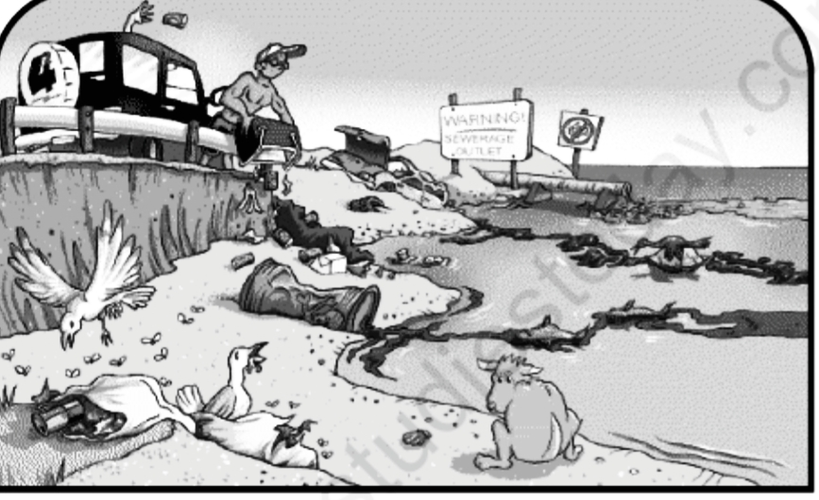
Why and how? (2)

